A plant-based diet is a diet primarily focused on consumption of plants such as nuts, seeds, grains, beans etc. Plant based diets do not always translate to veganism or vegetarianism.

**The nitrogen cycle (refer to figure 1):**

The nitrogen cycle is the cycle of which nitrogen is converted into different and multiple chemicals as it circulates in the atmosphere. The process doesn’t end and loops back for whichever happens. Now, for the explanation of the process of the nitrogen cycle and the processes that happen around the cycle. Let us start with the animal, living our life until we die. Luckily, we don’t go to waste and we are decomposed and then we are turned into ammonium (NH4). How exciting, we then proceed to nitrification and we become nitrites (NO2), and then nitrates (NO3). There are two paths we go from here; one is that we go into plants which can die and decompose or get eaten by an animal and have the process start again. And the second path is more interesting, we become atmospheric nitrogen (N2). From the atmosphere we go back into the soil and can either live with the legume roots or we can go back into ammonification and start all again.

**The carbon cycle:**

The carbon cycle is a biogeochemical cycle where carbon is traded among the earth’s different spheres; the atmosphere, the hydrosphere, biosphere, pedosphere, and the geosphere.  
the atmosphere is the layer that contains gasses, or air, if you will. These gasses are kept in place by earth’s gravity. The hydrosphere is the total water amount that is on the earth, including underground water and not just lakes and rivers. The biosphere pretty much represents and is the sum of all the ecosystems on the earth. It can also be known as the ecosphere. Pedosphere is simple, the most outer layer of the earth, composed of soils. Finally, we get to geosphere. The geosphere defines as the rocks, minerals, landforms of the surface and in the crust of the earth. Time to look at the carbon cycle. Now, we will start in the animal. Again. The animal will respire, releasing carbon. The animal will also release carbon after dying and decomposing. When respiring, the carbon is released into the atmosphere, where it becomes carbon dioxide (CO2). The carbon released from the decomposed animal also gets released into the atmosphere and becomes carbon dioxide (CO2). The decomposed animal will also compound into inorganic carbon which becomes organic carbon, which feeds into the plants. The cycle repeats itself now, the animal will either eat parts of the plant, or will breathe in oxygen produced by the plant.

**Brief description on climate change and how it links to plant-based diets:**

Refer to figure 3, this is the agricultural cycle. As observed in the image, you can see that Nitrous oxide, methane and carbon dioxide are released into the atmosphere from different ways. As you can see, fire will release methane, carbon dioxide and nitrous oxide. Methane can also be released from animals when they belch. Manure can release methane and nitrous oxide or be used as fertilizer which will eventually release carbon dioxide by soil respiration. According to europeanscientists.com, a shift to plant-based diets and limiting meat consumption by 60 grams per each person could reduce the agricultural emissions by up to 8 gigatons of carbon, yearly.

**Nitrogen cycle vs plant-based diet:**

In the nitrogen cycle, plants absorb nitrates from the soil to get their nitrogen. This is called assimilation. The nitrogen will be turned back into ammonium once the animal or plant has died and been decomposed. If you take the plants for the plant-based diets then not only will the plant not be able to be turned back into ammonium, it may also affect the animals as they also eat the plants. If there are limited plants, then there will be more animals going for the same plant and causing other animals to possibly die and releasing more nitrogen and causing the cycle to become unbalanced.

**Carbon cycle vs plant-based diet:**

The carbon cycle is simple, animals’ breath in oxygen and feed on the plants, they then breathe out carbon dioxide, which is taken in by the plants. When an animal or plant dies, it is decomposed and released as carbon dioxide. You could think of it as an infinite cycle. But then there were humans. Humans mostly eat meat, or animals, if you will. Some have “plant-based diets.” Now, according to (n/a, 2021); *researchers found that the diets of people who eat more than 3.5 ounces of meat per day—about the size of a deck of playing cards—generate 15.8 pounds of carbon-dioxide equivalent (CO2e) each day, whereas vegetarians and vegans are responsible for 8.4 pounds and 6.4 pounds of CO2e, respectively.*   
That’s almost half of the amount of CO2e generated when on a non-carnivorous diet, compared to the 7.4 pounds more that is made when eating meat. Too much carbon dioxide in the atmosphere will cause more heat to be trapped in the earth, like a greenhouse. Plant-based diets can be beneficial and will be beneficial, but the carbon cycle cannot recycle if there are no plants to photosynthesize. This will not likely happen as long as we are planting new plants when we take the old ones.

**Brief description on biodiversity and how plant-based diets are linked:**

Biodiversity is the diverse variety of life in the ecosystem and on earth. tbc

**Extension question:** How can the plant-based diet become more approachable to the larger population?

a plant-based diet for the human population could be possible. There are some people who already are on full plant-based diets, which is fine but them forcing this upon other people may influence the public in the other direction and to them not taking on a semi plant diet. We do not have to rule out meat altogether, it just needs to be controlled and limited. A start to this could be advertising how the cycles work and educating the population. Easing into this will take a fair while but in the end it will reduce emissions. tbc…

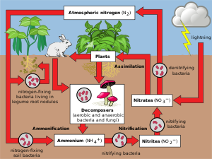**Figure 1: The Nitrogen Cycles**

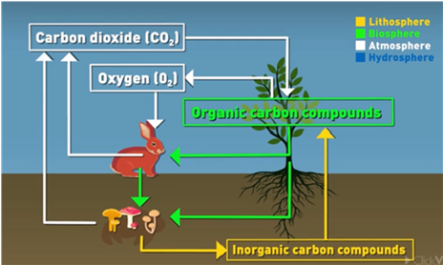

**Figure 2: The Carbon Cycle**

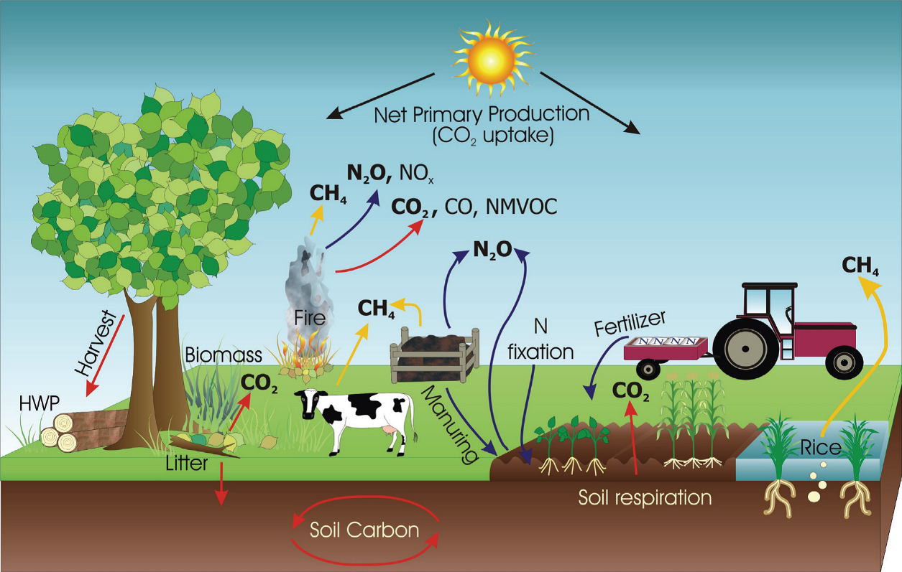

**Figure 3: The Agricultural Emissions Cycle**

<https://www.health.harvard.edu/blog/what-is-a-plant-based-diet-and-why-should-you-try-it-2018092614760>

<https://www.health.harvard.edu/staying-healthy/the-right-plant-based-diet-for-you>

<https://www.agci.org/earth-systems/geosphere>

<https://www.nationalgeographic.org/encyclopedia/hydrosphere/#:~:text=Powered%20by-,A%20hydrosphere%20is%20the%20total%20amount%20of%20water%20on%20a,of%20oceans%2C%20lakes%20and%20rivers>.

<https://www.europeanscientist.com/en/agriculture/shifting-to-plant-based-diets-crucial-in-fight-against-climate-change/#:~:text=Shifting%20to%20plant%2Dbased%20diets%20that%20are%20high%20in%20coarse,helping%20to%20mitigate%20climate%20change>.

https://www.peta.org/issues/animals-used-for-food/global-warming/#:~:text=The%20researchers%20found%20that%20the,of%20CO2e%2C%20respectively.

https://e360.yale.edu/features/the-nitrogen-problem-why-global-warming-is-making-it-worse#:~:text=New%20research%20shows%20that%20increases,polluting%20rivers%20and%20other%20waterways.&text=That's%20not%20counting%20likely%20increases,or%20from%20increased%20human%20population.

Conniff, 2017